Lecture 6.
Pathogenic fungi and protozoa
The purpose of the lecture: To inform students about the morpho-biological characteristics of pathogenic and opportunistic fungi and protozoa, pathogenic factors, pathogenesis of diseases caused by these microorganisms, clinical signs, principles of microbiological diagnosis, treatment and prevention.
Lecture plan:
1. Classification of fungi that are pathogenic to humans.
2. Classification of mycoses: superficial mycoses (keratomycoses), skin mycoses (dermatomycoses), subcutaneous mycoses (subcutaneous) mycoses, systemic or visceral mycoses and opportunistic mycoses.
3. Morpho-biological features of the causative agents of superficial mycoses (tinea versicolor, black and white piedra), principles of microbiological diagnosis of the diseases they cause
4. Morpho-biological characteristics of the causative agents of skin mycoses (trichophytia, epdermophytia, microsporia, favus), principles of microbiological diagnosis of the diseases they cause
5. Morpho-biological characteristics of the causative agents of subcutaneous mycoses (sporotrichosis, chromomycosis, misetoma), principles of microbiological diagnosis of the diseases they cause
6. Morpho-biological features of the causative agents of systemic (visseral) mycoses (coccidioidosis, histoplasmosis, blastomycosis, paracoccidioidosis), principles of microbiological diagnosis of the diseases they cause
7. Morpho-biological characteristics of the causative agents of opportunistic mycoses (candidiasis, cryptococcosis, aspergillosis, mucoromycosis, pneumocystosis), the principles of microbiological diagnosis of the diseases they cause
8. The concept of mycotoxicosis
9. Causative agents and classification of protozoan infections
10. Morpho-biological characteristics of protozoa belonging to the type Sarcomastigophora (sarcodines and flagellates), principles of microbiological diagnosis of diseases caused by them (amoebiasis, giardiasis, trichomoniasis, leishmaniasis, trypanosomosis)
11. Morpho-biological characteristics of the primitives belonging to the type Apicomplexa (spores), principles of microbiological diagnosis of diseases caused by them (malaria, toxoplasmosis)
12. Morpho-biological characteristics of the protozoa belonging to the type of Ciliophora (ciliated), principles of microbiological diagnosis of the diseases caused by them (balantidiosis)
13. Morpho-biological characteristics of protozoa belonging to the Microspora (invasion) type, principles of microbiological diagnosis of diseases caused by them (microsporidiosis)

Medically Important Fungi (Kingdom Fungi)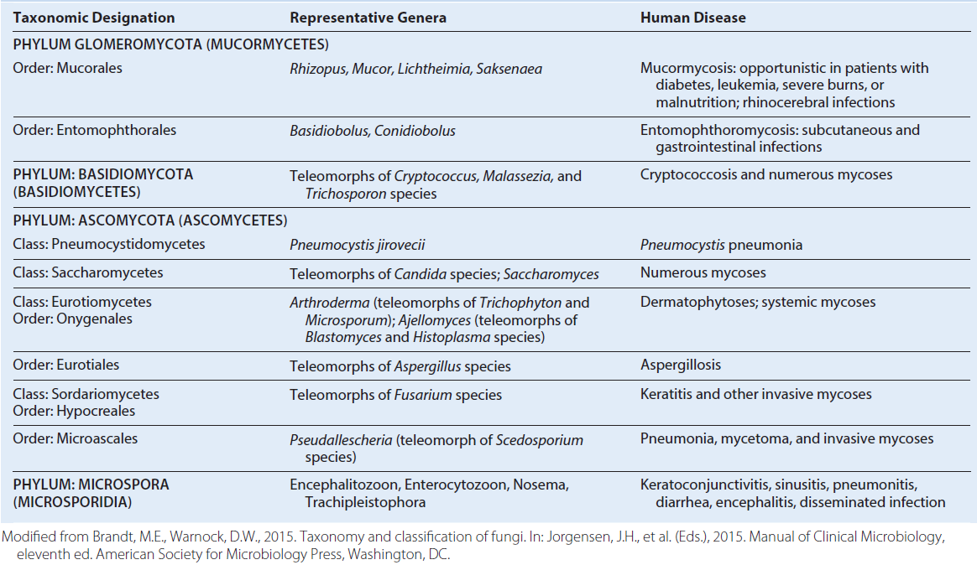
Classification of Human Mycoses and Representative Etiologic Agents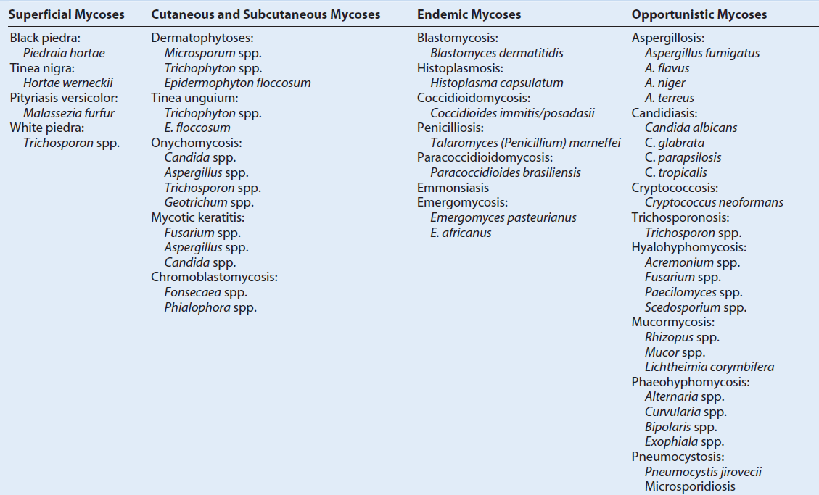
Characteristics of Primary and Opportunistic Fungal Pathogens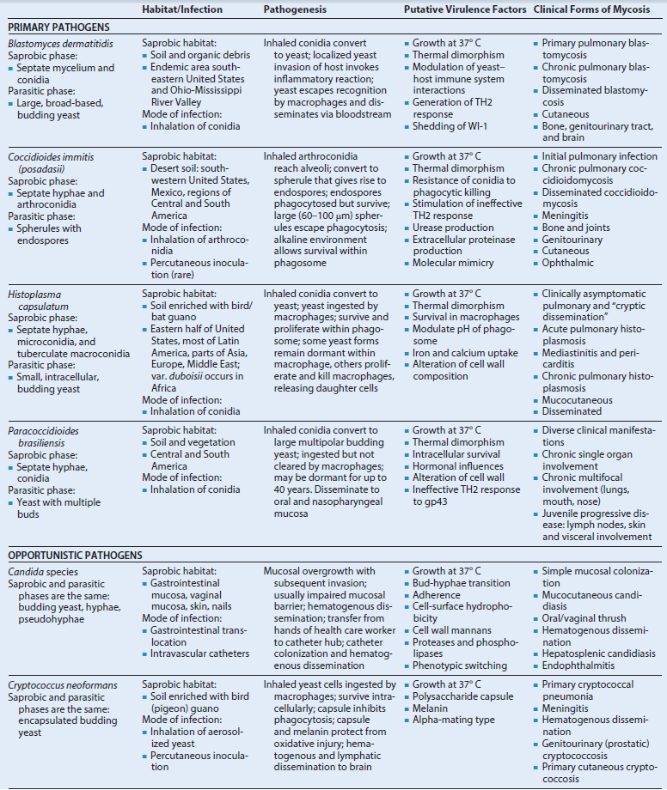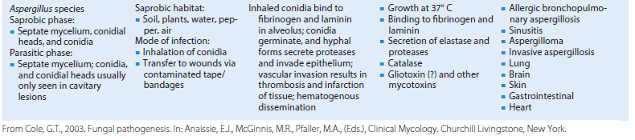
Mycotoxin-Related Illnesses Postulated to Affect Humans, Based on Analytic or Epidemiologic Data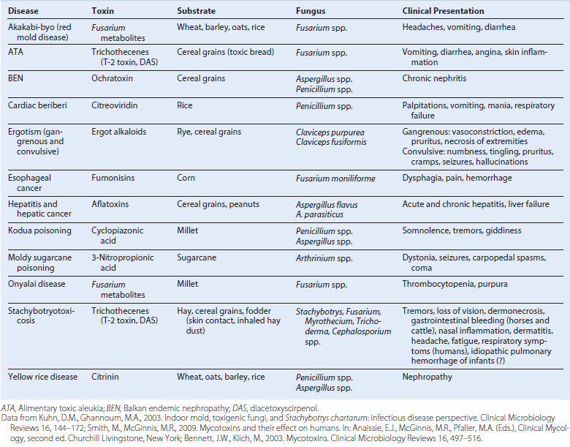
Summary of Fungi Associated with Human Disease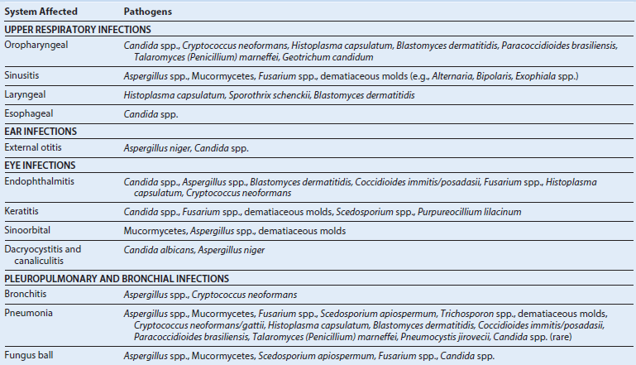
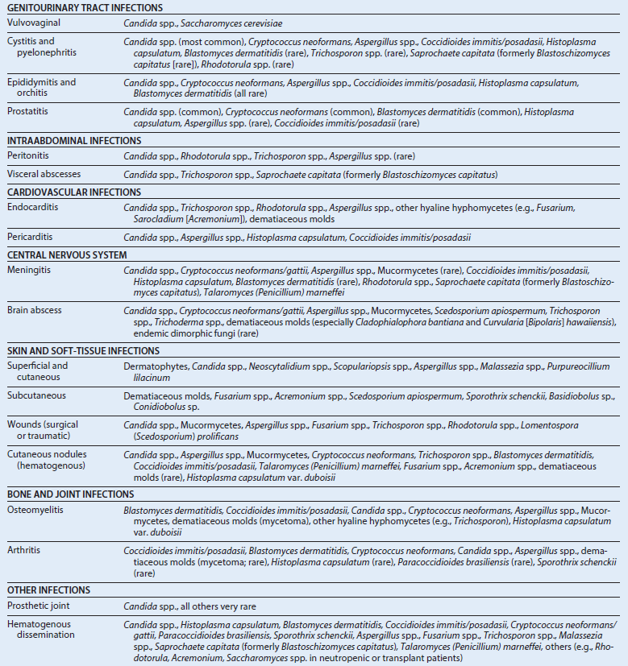
Antifungal spectrum: This is the range of activity of an antifungal agent against fungi. A broad-spectrum antifungal agent inhibits a wide variety of fungi, including both yeastlike fungi and molds, whereas a narrow-spectrum agent is active only against a limited number of fungi.
Fungistatic activity: This is the level of antifungal activity that inhibits the growth of an organism. This is determined in vitro by testing a standardized concentration of organisms against a series of antifungal dilutions. The lowest concentration of the drug that inhibits the growth of the organism is referred to as the MIC.
Fungicidal activity: This is the ability of an antifungal agent to kill an organism in vitro or in vivo. The lowest concentration of the drug that kills 99.9% of the test population is called the MFC.
Antifungal combinations: These combinations of antifungal agents may be used (1) to enhance efficacy in the treatment of a refractory fungal infection, (2) to broaden the spectrum of empiric antifungal therapy, (3) to prevent the emergence of resistant organisms, and (4) to achieve a synergistic killing effect.
Antifungal synergism: These are combinations of antifungal agents that have enhanced antifungal activity when used together compared with the activity of each agent alone.
Antifungal antagonism: This is a combination of antifungal agents in which the activity of one of the agents interferes with the activity of the other agent.
Efflux pumps: These are families of drug transporters that serve to actively pump antifungal agents out of the fungal cells, decreasing the amount of intracellular drug available to bind to its target.
MFC-Minimum fungicidal concentration; MIC-minimum inhibitory concentration.
Sites of action of antifungals.
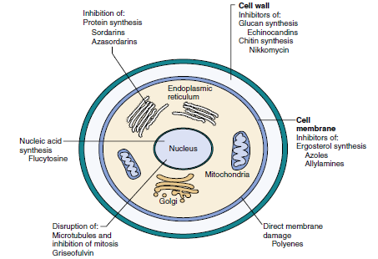
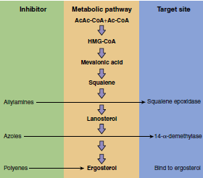 | Metabolic pathway for the synthesis of ergosterol, showing sites of inhibition by allylamine, azole, and polyene antifungal agents. Ac-CoA, Acetyl-coenzyme A; HMG-CoA, hydroxymethyl glutaryl-coenzyme A.
Systemic and Topical Antifungal Agents in Use and in Development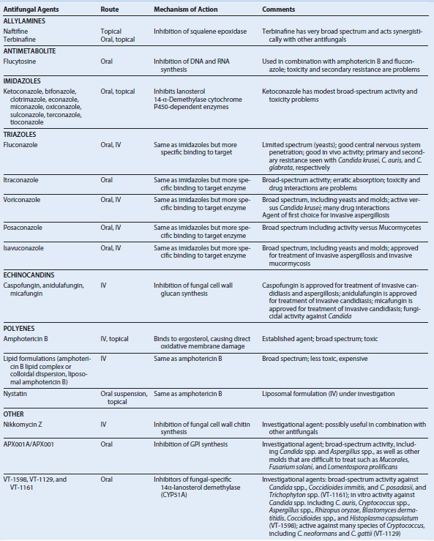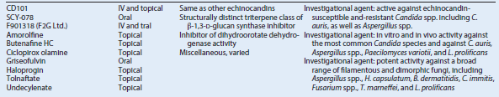
DERMATOPHYTES
Trigger Words Tinea, KOH preparation, ringworm, azoles, terbinafine, circular, scaling lesion with central clearing and hair loss
Biology, Virulence, and Disease
• Include filamentous fungi in the genera Trichophyton, Epidermophyton, and
Microsporum
• Keratinophilic and keratinolytic; able to invade and break down skin, hair, and nails
• In infections of skin, hair, and nails, only outermost keratinized layers invaded
• Various forms of dermatophytosis (tineas or “ringworm”) classified according to anatomic site or structure involved
• Clinical signs and symptoms vary
Epidemiology
• Classified into three categories based on natural habitat: geophilic, zoophilic, and anthropophilic
• Geophilic: live in soil, occasional pathogens of both animals and humans
• Zoophilic: parasitize hair and skin of animals but can be transmitted to humans
• Anthropophilic: infect humans, may be transmitted directly or indirectly from person to person
• Occur worldwide, especially in tropical and subtropical regions
Treatment, Prevention, and Control
• Localized infections that do not involve hair or nails may be treated effectively with topical antifungal agents (azoles, terbinafine, haloprogin)
• All others require oral therapy (griseofulvin, itraconazole, fluconazole, terbinafine)
Common and Uncommon Agents of Superficial and Cutaneous Dermatomycoses and Dermatophytoses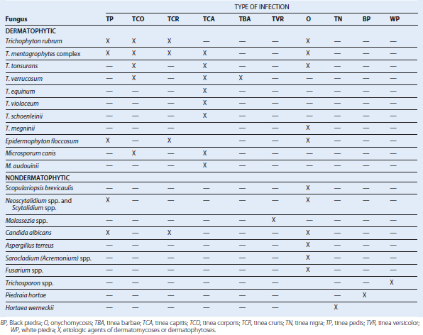
Classification of Dermatophytes According to Ecologic Niche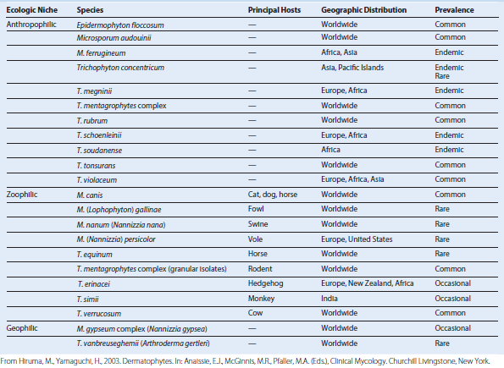
Subcutaneous Mycoses
SPOROTRICHOSIS (Sporothrix schenckii)
Trigger Words-Thorn prick, rose handler’s disease, sphagnum moss, lymphocutaneous nodules
Biology, Virulence, and Disease
ᑏᑏ Thermally dimorphic fungus; grows as a mold at room temperature (e.g., 25° C) and as a pleomorphic yeast at 37° C and in tissue
ᑏᑏ Infection is chronic; nodular and ulcerative lesions develop along lymphatics that drain primary site of inoculation
Epidemiology
ᑏᑏ Sporadic, most common in warmer climates: Japan, North and South America
ᑏᑏ Outbreaks related to forest work, mining, gardening
ᑏᑏ Classic infection associated with traumatic inoculation of soil, vegetable, or organic matter contaminated with fungus
ᑏᑏ Zoonotic transmission reported in armadillo hunters and in association with infected cats
Diagnosis
ᑏᑏ Subcutaneous infection with lymphangitic spread
ᑏᑏDefinitive diagnosis requires culture of infected pus or tissue
ᑏᑏ In tissue, organism appears as a pleomorphic budding yeast
Treatment, Prevention, and Control
ᑏᑏ Classic treatment: oral potassium iodide in saturated solution
ᑏᑏ Itraconazole: safe, highly effective, treatment of choice
ᑏᑏ Alternatives: terbinafine, fluconazole, posaconazole
ᑏᑏ Local application of heat shown to be effective

EUMYCOTIC MYCETOMA
(Phaeoacremonium, Curvularia, Fusarium, Madurella, Mediacopsis, Nigrograna, Trematosphaeria, Exophiala, Falciformispora, AND Scedosporium species)
Trigger Words-Grains, sinus tract, dematiaceous, subcutaneous, mycetoma
Biology, Virulence, and Disease
ᑏᑏ Caused by a wide array of true fungi (as opposed to actinomycotic mycetomas, which are caused by bacteria)
ᑏᑏ Localized chronic granulomatous infectious process involving cutaneous and subcutaneous tissues
ᑏᑏ Painless subcutaneous nodule; increases slowly but progressively in size
ᑏᑏ Local spread may breach tissue planes, destroying muscle, fascia, and bone
ᑏᑏ Hematogenous or lymphatic spread rare
Epidemiology
ᑏᑏ Primarily in tropical areas with low rainfall; most common in Africa and India
ᑏᑏ Traumatic implantation into exposed body parts; foot and hand most common; back, shoulders, chest wall may also be involved
ᑏᑏ Men more often affected than women
ᑏᑏ Etiologic agent varies from country to country
ᑏᑏ Mycetomas not contagious
Diagnosis
ᑏᑏDemonstration of grains or granules grossly visible in draining sinus tracts; may also be seen on tissue biopsy
ᑏᑏMicroscopic examination of granules
ᑏᑏCulture usually needed for identification of organism
Treatment, Prevention, and Control
ᑏᑏ Usually unsuccessful; poor response to most antifungal agents
ᑏᑏ Specific antifungal therapy may slow progression: terbinafine, voriconazole, posaconazole
ᑏᑏ Local excision usually ineffective; amputation is the only definitive treatment

ENTOMOPHTHOROMYCOSIS
(Conidiobolus coronatus AND Basidiobolus ranarum)
Trigger Words-Entomophthoromycosis, subcutaneous, Splendore-Hoeppli, mucormycotic
Biology, Virulence, and Disease
ᑏᑏ Subcutaneous entomophthoromycosis caused by Mucormycetes of the order Entomophthorales: Conidiobolus coronatus, Basidiobolus ranarum
ᑏᑏ Chronic subcutaneous form of mucormycosis
ᑏᑏ Occurs sporadically as a result of subcutaneous implantation or inhalation of fungus present in plant debris
ᑏᑏ B. ranarum: infection presents with disk-shaped, rubbery, moveable masses localized to shoulder, pelvis, hips, thighs; may become quite large and ulcerate
ᑏᑏ C. coronatus: confined to rhinofacial area; facial deformity may be quite dramatic
ᑏᑏ Angioinvasion does not occur; dissemination or involvement of deep structures rare
Epidemiology
ᑏᑏ Both types seen most commonly in Africa, India
ᑏᑏ Both fungi are saprophytes present in leaf and plant debris
ᑏᑏ Rare diseases without known predisposing factors
ᑏᑏ B. ranarum: infection occurs after traumatic implantation of fungus into subcutaneous tissues of thighs, buttocks, trunk; occurs mainly in children; male/female ratio 3:1
ᑏᑏ C. coronatus: infection occurs after inhalation of fungal spores, with subsequent invasion of tissues of nasal cavity, paranasal sinuses, facial soft tissues; predominantly seen in young adults; male/female ratio 10:1
Diagnosis
ᑏᑏClinical diagnosis usually evident based on gross physical appearance
ᑏᑏ Both types of subcutaneous entomophthoromycosis require biopsy for definitive diagnosis
Treatment, Prevention, and Control
ᑏᑏ Both types of infection may be treated with itraconazole; oral potassium iodide in saturated solution may be used
ᑏᑏ Facial reconstructive surgery may be necessary in the case of C. coronatus infection

Common Agents of Subcutaneous Mycoses 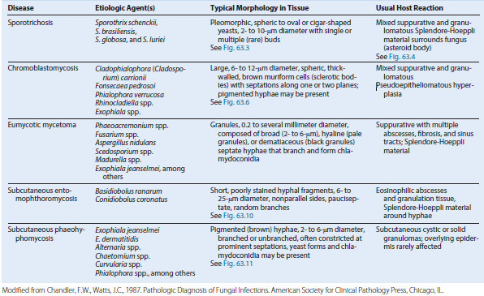

SYSTEMIC MYCOSES CAUSED BY DIMORPHIC FUNGI

BLASTOMYCOSIS (BLASTOMYCES DERMATITIDIS AND B. GILCHRISTII)
Trigger Words-Mississippi River Valley, broad-based budding yeast, healthy and immunocompromised, granuloma
Biology, Virulence, and Disease
ᑏᑏ Thermally dimorphic fungus: large nonencapsulated budding yeast cells in tissue and in culture at 37° C; mold colonies form in culture at 25°C
ᑏᑏUsual route of infection is inhalation of conidia
ᑏᑏ Severity of symptoms and course of disease depends on extent of exposure and immune status of exposed individual; most are asymptomatic
ᑏᑏClassic form of blastomycosis: chronic cutaneous involvement
Epidemiology
ᑏᑏ Ecologic niche: decaying organic matter
ᑏᑏ Area of endemicity: southeastern and southcentral states, especially bordering Ohio and Mississippi river basins; Midwest states and Canadian provinces bordering Great Lakes; and an area in New York and Canada along the St. Lawrence River
ᑏᑏ Outbreaks of infection have been associated with occupational or recreational contact with soil
Diagnosis
ᑏᑏMicroscopic detection of fungus in tissue or other clinical material, with confirmation by culture
ᑏᑏAntigen detection and PCR
Treatment, Prevention, and Control
ᑏᑏ Pulmonary blastomycosis in immunocompromised patients and those with progressive pulmonary disease should be treated
ᑏᑏ All patients with evidence of hematogenous dissemination require antifungal therapy
ᑏᑏ Lipid formulation of amphotericin B: treatment of choice for meningeal disease and other life-threatening presentations
ᑏᑏ Mild or moderate disease: itraconazole; fluconazole, posaconazole, or voriconazole may be substituted for itraconazole

COCCIDIOIDOMYCOSIS (COCCIDIOIDES IMMITIS AND C. POSADASII)
Trigger Words-Valley fever, coccidioidal granuloma, arthroconidia, spherule, skin test, precipitin test
Biology, Virulence, and Disease
ᑏᑏ Coccidioidomycosis caused by two indistinguishable species: C. immitis and C. posadasii
ᑏᑏ C. immitis is localized to California; C.posadasii causes most infections outside California
ᑏᑏ Disease caused by inhalation of infectious arthroconidia
ᑏᑏ Asymptomatic or subclinical, self-limited flulike illness, acute and chronic pulmonary disease, single or multisystem dissemination
ᑏᑏ Dimorphic fungi; endosporulating spherule in tissue, mold in culture at 25° C and in nature
Epidemiology
ᑏᑏ Endemic to U.S. southwestern desert, northern Mexico, scattered areas of Central and South America
ᑏᑏ Organism found in soil; growth in environment enhanced by bat and rodent droppings; cycles of drought/rain enhance organism dispersion
ᑏᑏ Persons ≥65 years and those with HIV infection disproportionately affected
ᑏᑏ Risk of disseminated disease highest in certain ethnic groups (Filipino, African American, Native American, Hispanic), males (9:1), women in third trimester of pregnancy, individuals with cellular immune deficiency, persons at extremes of age
Diagnosis
ᑏᑏHistopathologic examination of tissue or other clinical material, isolation of fungus in culture, serology
ᑏᑏHistopathologic examination that reveals endosporulating spherules in sputum, exudates, or tissue is sufficient to establish the diagnosis
ᑏᑏCulture at 25° C takes days and poses risk to laboratory workers; all work with molds should be performed in suitable biosafety cabinet
ᑏᑏ Serology (antigen and antibody) may be useful for initial screening, confirmation, or prognostic evaluation
Treatment, Prevention, and Control
ᑏᑏ Most individuals with primary infection do not require therapy
ᑏᑏ For those with concurrent risk factors or a more severe presentation: lipid formulation of amphotericin B followed by an oral azole as maintenance therapy (severe disease)
ᑏᑏ Chronic cavitary pulmonary disease: azole for at least 1 year
ᑏᑏ Nonmeningeal extrapulmonary disseminated infections: oral azole
ᑏᑏ Meningeal coccidioidomycosis: fluconazole; itraconazole, posaconazole or voriconazole are secondary choices

HISTOPLASMOSIS (HISTOPLASMA CAPSULATUM)
Trigger Words-Intracellular yeasts, bird and bat droppings, chicken coop, caves, guano, granulomas
Biology, Virulence, and Disease
ᑏᑏ Histoplasmosis caused by two varieties of H. capsulatum
ᑏᑏ H. capsulatum var. capsulatum: causes pulmonary and disseminated infections
ᑏᑏ H. capsulatum var. duboisii: causes predominantly skin and bone lesions
ᑏᑏ Disease caused by inhalation of infectiousmicroconidia
ᑏᑏ Severity of symptoms and course of disease depend on extent of exposure and immune status of infected individual; most are asymptomatic, self-limited; flulike illness also occurs
ᑏᑏ Thermally dimorphic fungus: hyaline mold in nature and in culture at 25° C, budding yeast in tissue (intracellular) and in culture at 37° C
Epidemiology
ᑏᑏ H. capsulatum var. capsulatum: localized to Ohio and Mississippi river valleys; occurs throughout Mexico and Central and South America
ᑏᑏ H. capsulatum var. duboisii: confined to tropical Africa (e.g., Gabon, Uganda, Kenya)
ᑏᑏ Found in soil with high nitrogen content (e.g., areas contaminated with bird or bat droppings)
ᑏᑏ Outbreaks of disease have been associated with exposure to bird roosts, caves, and decaying buildings or urban renewal projects involving excavation and demolition
ᑏᑏ Immunocompromised individuals and children most prone to develop symptomatic disease
ᑏᑏ Reactivation of disease and dissemination common among immunosuppressed individuals, especially those with AIDS
Diagnosis
ᑏᑏDirect microscopy, culture of clinical material, serology (antigen and antibody), β-D-glucan, and PCR have been useful
ᑏᑏ Yeast phase of organism can be detected in sputum, bronchoalveolar lavage fluid, peripheral blood films, bone marrow, and tissue stained with Giemsa, GMS, or PAS stains
ᑏᑏCultures should be handled in a biosafety cabinet
ᑏᑏ Serologic diagnosis includes tests for antibody and antigen
Treatment, Prevention, and Control
ᑏᑏ Severe acute infections: lipid formulation of amphotericin B followed by oral itraconazole
ᑏᑏ Chronic pulmonary histoplasmosis: lipid formulation of amphotericin B followed by itraconazole
ᑏᑏ Disseminated infection: lipid formulation of amphotericin B followed by itraconazole

PARACOCCIDIOIDOMYCOSIS (PARACOCCIDIOIDES BRASILIENSIS AND P. LUTZII)
Trigger Words-Pilot’s wheel, South American blastomycosis, ulcer, multiple buds
Biology, Virulence, and Disease
- Thermally dimorphic fungus: slowly growing mold phase in nature and at 25° C, yeast phase (variable sized with single or multiple buds) in tissue and in culture at 37° C
- Usual route of infection is inhalation or possible traumatic inoculation of conidia or hyphal fragments
- Paracoccidioidomycosis may be subclinical or progressive with acute or chronic pulmonary forms or acute, subacute, or chronic disseminated forms
Epidemiology
- Endemic throughout Latin America, areas of high humidity, rich vegetation, moderate temperatures, acid soil
- Ecologic niche not well established
- Overt disease uncommon among children and adolescents; in adults, disease more common in men aged 30 to 50 years
- Most patients with clinically apparent disease live in rural areas and have close contact with soil
- No reports of epidemics or person-toperson transmission
Diagnosis
ᑏᑏDemonstration of characteristic yeastforms on microscopic examination of clinical material: oval to round with double refractile walls and single or multiple buds; “pilot-wheel” morphology
ᑏᑏMay be isolated in culture and should be handled in a biosafety cabinet
ᑏᑏ Serology testing may help in suggesting diagnosis, evaluating response to therapy
Treatment, Prevention, and Control
- Itraconazole: treatment of choice for most forms of disease
- More severe or refractory forms: lipid formulation of amphotericin B followed by either itraconazole or sulfonamide therapy
Characteristics of Endemic Dimorphic Mycoses 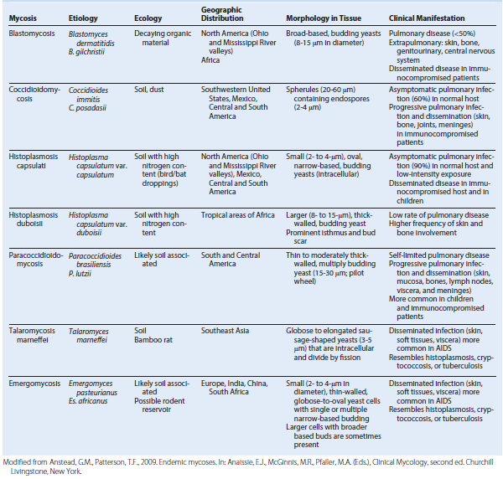

OPPORTUNISTIC MYCOSES
CANDIDIASIS
Trigger Words-Candida, pseudohyphae, endogenous, exogenous, yeast, immunocompromised, vaginal thrush, oropharyngeal
Biology, Virulence, and Disease
ᑏᑏ Opportunistic yeasts causing infections ranging from superficial mucosal and cutaneous disease to hematogenously disseminated, often fatal, infections
ᑏᑏ Vast majority of infections are caused by five major species: Candida albicans, C. glabrata, C. parapsilosis, C. tropicalis, and C. krusei
ᑏᑏ Morphology ranges from budding yeasts to pseudohyphae and true hyphae
ᑏᑏ Reproduction is by formation of blastoconidia (buds)
ᑏᑏ Most important group of opportunistic fungal pathogens
ᑏᑏ May be community acquired (mucosal infections) or hospital associated (invasive disease)
Epidemiology
ᑏᑏ Candida spp. are known colonizers of humans and other warm-blooded animals
ᑏᑏ Primary site of colonization is the GI tract; commensals in the vagina, urethra, skin, and nails
ᑏᑏ Most infections are endogenous, involving normally commensal host flora
ᑏᑏ Exogenous transmission in hospitals also occurs
ᑏᑏ C. albicans predominates in most types of infection
ᑏᑏ Consequences of Candida BSIs are severe; risk factors include hematologic malignancies and neutropenia, abdominal surgery, prematurity in infants, and age >70 years
Diagnosis
ᑏᑏClinical appearance, direct microscopic examination, and culture
ᑏᑏHematogenously disseminated infections and candidemia difficult to diagnose on clinical grounds alone
ᑏᑏ Laboratory diagnosis involves procurement of appropriate clinical material, followed by direct microscopic examination; culture; and (increasingly) application of molecular, antigenic, and proteomic analysis
Treatment, Prevention, and Control
ᑏᑏ Mucosal and cutaneous infection: topical and systemically active antifungal agents include azoles (itraconazole, fluconazole, miconazole, and many others), polyenes (amphotericin B and nystatin)
ᑏᑏ Invasive candidiasis and candidemia: oral or intravenous administration depending on antifungal agent and severity of disease and/or immunosuppression; azoles (fluconazole, voriconazole, posaconazole, isavuconazole), echinocandins (anidulafungin, caspofungin, micafungin), amphotericin B formulations (deoxycholate and lipid formulations), flucytosine

CRYPTOCOCCOSIS
Trigger Words-Capsule, budding yeast, CNS, neurotropic, India ink, antigen, AIDS
Biology, Virulence, and Disease
ᑏᑏ Systemic mycosis caused by the fungi Cryptococcus neoformans and C. gattii
ᑏᑏ C. neoformans includes capsular serotypes A, D, and AD; var. grubii (serotype A) and var. neoformans (serotype D)
ᑏᑏ C. gattii includes serotypes B and C
ᑏᑏ Spherical to oval, encapsulated, yeastlike organisms that replicate by budding
ᑏᑏ Both species may cause pulmonary, hematogenously disseminated, and CNS disease
Epidemiology
ᑏᑏ Usually acquired by inhaling aerosolized cells of C. neoformans and C. gattii
ᑏᑏ Both species pathogenic for immunocompetent individuals
ᑏᑏ C. neoformans: most often encountered as opportunistic pathogen; found worldwide in soil contaminated with avian excreta
ᑏᑏ C. gattii: found in tropical and subtropical climates in association with eucalyptus trees; the focus in the Pacific Northwest has been associated with Douglas fir trees
ᑏᑏ Disease is similar, although C. gattii infection tends to occur in immunocompetent individuals and has a lower associated mortality
ᑏᑏ Incidence has progressively declined since early 1990s because of widespread use of fluconazole and successful treatment of HIV infection with antiviral drugs
Diagnosis
ᑏᑏMay present as pneumonic process or (more commonly) as CNS infection
ᑏᑏDiagnosis may be made by culture of blood, CSF, or other clinical material
ᑏᑏMicroscopic examination of CSF may reveal characteristic encapsulated budding yeast cells
ᑏᑏCryptococcal meningitis: diagnosis by detection of polysaccharide antigen in serum or CSF
Treatment, Prevention, and Control
ᑏᑏ Cryptococcal meningitis and other disseminated forms universally fatal if left untreated
ᑏᑏ Antifungal therapy: amphotericin B (deoxycholate or lipid formulation) plus flucytosine followed by maintenance/consolidation therapy with fluconazole (preferred) or itraconazole
ᑏᑏ Effective management of CNS pressure and IRIS crucial to successful management of cryptococcal meningitis

ASPERGILLOSIS
Trigger Words-Septate branching hyphae, hypersensitivity pneumonitis, angioinvasive, aspergilloma, conidia
Biology, Virulence, and Disease
ᑏᑏ Broad spectrum of diseases caused by filamentous fungi (molds) of genus Aspergillus
ᑏᑏ Exposure to spores in environment may cause allergic reactions in hypersensitized hosts or destructive, invasive, pulmonary, and disseminated disease in highly immunocompromised hosts
ᑏᑏ Vast majority of infections caused by A.fumigatus (most common), A. flavus, A.niger, and A. terreus
ᑏᑏ Hyaline molds that produce vast amounts of spores (conidia) that serve as infectious propagules on inhalation by host
ᑏᑏ Invasive aspergillosis marked by angioinvasion and tissue destruction caused by infarction
ᑏᑏ Hematogenous dissemination of infection to extrapulmonary sites (most commonly brain, heart, kidneys, GI tract, liver, spleen)
common because of angioinvasive nature of fungus
Epidemiology
ᑏᑏ Aspergillus spp. common worldwide; conidia ubiquitous in air, soil, decaying matter
ᑏᑏ Within hospital environment, Aspergillus spp. may be found in air, showerheads, water storage tanks, potted plants
ᑏᑏ Conidia (spores) constantly being inhaled; respiratory tract most frequent and important portal of entry
ᑏᑏ Host reaction, associated pathologic findings, and outcome of infection depend more on host factors than virulence or pathogenesis of individual species
Diagnosis
ᑏᑏ Serologic, culture, histopathologic, molecular, biochemical, and antigenic methods supplemented by imaging studies
Treatment, Prevention, and Control
ᑏᑏ Treatment usually involves administration of corticosteroids coupled with pulmonary toilet
ᑏᑏ Treatment of chronic pulmonary aspergillosis may involve steroids and long-term antifungal therapy, usually with an azole antifungal agent
ᑏᑏ Prophylaxis of high-risk (neutropenic) patients usually accomplished by administration of a mold-active azole (itraconazole, posaconazole, voriconazole)
ᑏᑏ Specific antifungal therapy of invasive aspergillosis usually involves administration of voriconazole or a lipid formulation of amphotericin B; isavuconazole has recently been cleared by the U.S. Food and Drug Administration for treatment of invasive aspergillosis
ᑏᑏ Efforts to decrease immunosuppression and/or reconstitute host immune defenses important, as is surgical resection of infected tissue if possible
ᑏᑏ Resection of aspergillomas only considered in instances of severe hemoptysis
BSI, Bloodstream infections; CNS, central nervous system; CSF, cerebrospinal fluid; GI, gastrointestinal; IRIS, immune reconstitution inflammatory syndrome.
Agents of Opportunistic Mycoses
Candida spp.  C. albicans  C. glabrata  C. parapsilosis  C. tropicalis  C. krusei  C. lusitaniae  C. guilliermondii  C. dubliniensis  C. rugosa  C. auris | Microsporidia Aspergillus spp.  A. fumigatus  A. flavus  A. niger  A. versicolor  A. terreus
Cryptococcus Neoformans and Other Opportunistic Yeastlike Fungi  C. neoformans/gattii  Malassezia spp.  Trichosporon spp.  Rhodotorula spp.  Saprochaete capitata | Mucormycetes  Rhizopus spp.  Mucor spp.  Rhizomucor spp.  Lichtheimia corymbifera  Cunninghamella spp.
Other Hyaline Molds  Fusarium spp.  Sarocladium spp.  Paecilomyces spp.  Purpureocillium lilacinum  Trichoderma spp.  Scopulariopsis spp. | Dematiaceous Molds  Alternaria spp.  Bipolaris spp.  Cladophialophora spp.  Curvularia spp.  Exophiala spp.  Exserohilum spp.  Lomentospora prolificans  Scedosporium spp.  Wangiella spp.
 | Pneumocystis jirovecii

SPECTRUM OF DISEASES CAUSED BY ASPERGILLUS SPECIES
Allergic Reactions-Nasal cavity, Paranasal sinuses, Lower respiratory tract
Colonization-Obstructed paranasal sinuses, Bronchi, Preformed pulmonary cavities
Superficial Cutaneous Infections-Wounds, Catheter sites
Limited Invasive Infections-Bronchi, Pulmonary parenchyma, Mildly immunodeficient patients
Frankly Invasive Pulmonary Infection-Severely immunodeficient patients,
Systemic dissemination, Death
Fungal and Fungal-Like Infections of Unusual or Uncertain Etiology
CHLORELLOSIS
Trigger Words-Chloroplasts, green lesions, water exposure, alga
Biology, Virulence, and Disease
ᑏᑏ Infection of humans and animals caused by a unicellular green alga of genus Chlorella
ᑏᑏ Chlorella: unicellular, ovoid, spherical or polygonal, reproduce by endosporulation
ᑏᑏ Fresh lesions in liver, lymph nodes, cutaneous tissue are green on gross examination; smears reveal organisms that contain green refractile granules (chloroplasts)
ᑏᑏ A single human infection reported thus far; most infections occur in sheep and cattle
Epidemiology
ᑏᑏ A single human infection in Nebraska; resulted from exposure of a surgical wound to river water
ᑏᑏ Infections in domestic and wild animals range from lymph node and deep organ involvement to cutaneous and subcutaneous lesions, presumably related to exposure to water containing the organism
Diagnosis
ᑏᑏChlorella spp. infections diagnosed by culture and histopathologic examination of infected tissue
ᑏᑏOn culture, colonies are bright green
ᑏᑏWet mounts of wound exudate or touch preparations of infected tissue reveal ovoid, endosporulating cells with characteristic green cytoplasmic granules
ᑏᑏ In tissue, cells stain with GMS and PAS but not H&E stains
Treatment, Prevention, and Control
ᑏᑏ Repeat debridement, irrigation with Dakin solution, gauze packing and removal for drainage and granulation
ᑏᑏ Amphotericin B therapy combined with administration of tetracycline may be useful
LACAZIOSIS
Trigger Words-Cutaneous trauma, soil, vegetation, water, dolphins, cutaneous nodules, tropical
Biology, Virulence, and Disease
ᑏᑏ Chronic fungal skin infection caused by Lacazia loboi
ᑏᑏ L. loboi: ascomycete fungus, reproduces by sequential budding, forms chains of spherical to oval cells connected by narrow tubelike bridges
ᑏᑏ Slowly developing cutaneous nodules of varying size and shape
ᑏᑏ Nodular keloid-like lesions most common; occur on the face, ears, arms, legs, feet
ᑏᑏ Lesions increase in size and number over a period of 40 to 50 years
ᑏᑏ Most patients asymptomatic; no systemic manifestations of disease
Epidemiology
ᑏᑏ Human disease endemic in tropical regions of Central and South America
ᑏᑏ L. loboi considered a saprophyte of soil and vegetation
ᑏᑏ Mode of infection: cutaneous trauma; occurs in individuals involved in farming and jungle clearing
ᑏᑏ Lacaziosis occurs in both marine and fresh water dolphins, suggesting an aquatic reservoir
Diagnosis
ᑏᑏ Based on demonstrating yeast cells in lesion exudate or tissue sections
ᑏᑏ Biopsy reveals a dispersed granulomatous infiltrate and numerous fungal forms in dermis and subcutaneous tissue
Treatment, Prevention, and Control
ᑏᑏ Surgical excision of localized lesions
ᑏᑏ Does not respond to antifungal therapy
RHINOSPORIDIOSIS
Trigger Words-Polypoid lesions, oropharynx, sporangium, trophocyte, endoconidia, granulomatous
Biology, Virulence, and Disease
ᑏᑏ Granulomatous disease of humans and animals caused by Rhinosporidium seeberi
ᑏᑏ Characterized by development of nasopharyngeal and ocular conjunctival polyps
ᑏᑏ Two developmental forms seen in tissue: a large spherical form (sporangia) and a smaller trophic form
Epidemiology
ᑏᑏ≈90% of all known cases of rhinosporidiosis occur in India and Sri Lanka
ᑏᑏ Natural habitat unknown
ᑏᑏ Occurs primarily in men aged 20 to 40
ᑏᑏ Appears to be associated with both rural and aquatic environments
ᑏᑏ No evidence rhinosporidiosis is contagious
Diagnosis
ᑏᑏHistopathologic examination of affected tissues; distinctive appearance of trophocytes and sporangia in routine H&Estained
tissue is diagnostic
ᑏᑏ R. seeberi has not been grown in culture
Treatment, Prevention, and Control
ᑏᑏ Only effective form of treatment is surgical excision of lesions
ᑏᑏ Recurrences common
ESTIMATED DISEASE BURDEN OF PARASITIC INFECTIONS
Medically Important Parasites
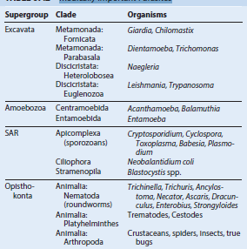

Biologic, Morphologic, and Physiologic Characteristics of Pathogenic Parasites
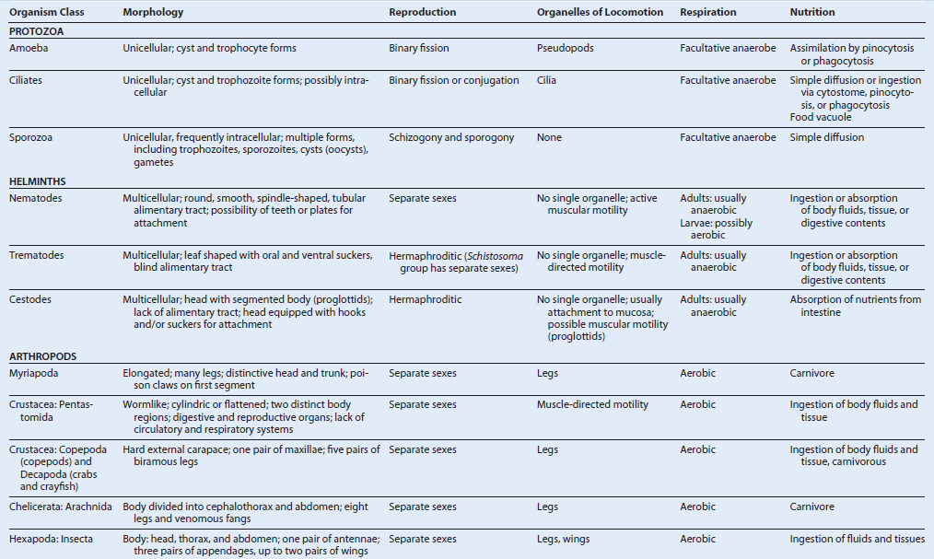

Transmission and Distribution of Pathogenic Parasites 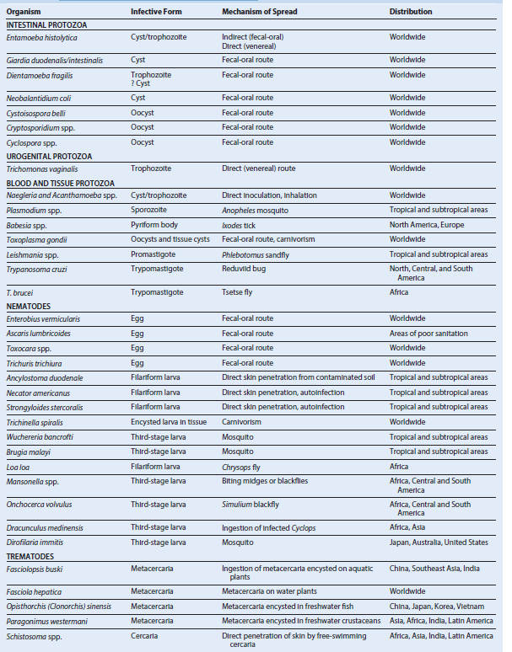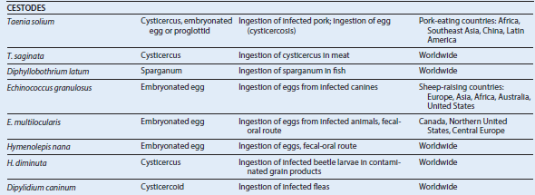
Factors Associated with Parasite Pathogenicity
Infective dose and exposure
Penetration of anatomic barriers
Attachment
Replication
Cell and tissue damage
Disruption, evasion, and inactivation of host defenses
Parasite Ports of Entry
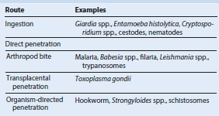
Examples of Parasitic Adherence Mechanisms
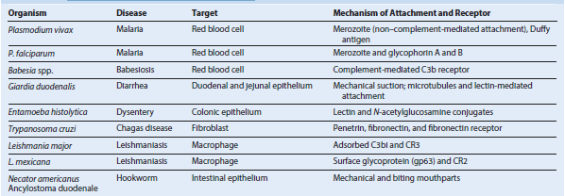
Some Pathologic Mechanisms in Parasitic Diseases
TOXIC PARASITE PRODUCTS
Hydrolytic enzymes, proteinases, collagenase, elastase - Schistosomes (cercariae), Strongyloides spp., hookworm, Entamoeba histolytica,
African trypanosomes, Plasmodium falciparum
Amebic ionophore - E. histolytica
Endotoxins - African trypanosomes, P. falciparum
Indole catabolites - Trypanosomes
MECHANICAL TISSUE DAMAGE
Blockage of internal organs - Ascaris spp., tapeworms, schistosomes, filaria
Pressure atrophy - Echinococcus spp., Cysticercus spp.
Migration through tissue - Helminthic larvae
IMMUNOPATHOLOGY
Hypersensitivity
Autoimmunity
Protein-losing enteropathies - Hookworm, tapeworm, Giardia spp., Strongyloides spp.
Metaplastic changes - Opisthorchis spp. (liver flukes), schistosomes
Immunopathologic Reactions to Parasitic Disease 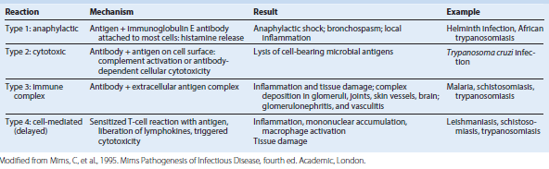
Microbial Interference with or Avoidance of Immune Defenses
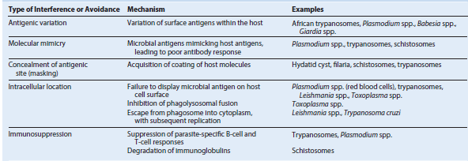

SUMMARY OF PARASITES ASSOCIATED WITH HUMAN DISEASE
BLOOD
Malaria - Plasmodium falciparum, P. knowlesi, P. malariae, P. ovale, P. vivax
Babesiosis - Babesia spp.
Filariasis - Wuchereria bancrofti, Brugia malayi, Mansonella spp., Loa loa
BONE MARROW
Leishmaniasis - Leishmania donovani, L. tropica
CENTRAL NERVOUS SYSTEM
Meningoencephalitis - Naegleria fowleri, Trypanosoma brucei gambiense, T. b. rhodesiense, T. cruzi, Toxoplasma gondii
Granulomatous encephalitis - Acanthamoeba spp., Balamuthia mandrillaris
Mass lesion, Brain abscess - T. gondii, Taenia solium, Schistosoma japonicum, Acanthamoeba spp., B. mandrillaris
Eosinophilic meningitis, Cerebral malaria - Angiostrongylus cantonensis, Toxocara spp., Baylisascaris (neural larva migrans), P. falciparum
Cerebral paragonimiasis - Paragonimus westermani
EYE
Keratitis - Acanthamoeba spp., Onchocerca volvulus
Chorioretinitis, Conjunctivitis - T. gondii, O. volvulus, L. loa
Ocular cysticercosis (mass lesion) - T. solium
Toxocariasis - Toxocara spp. (ocular larva migrans; mimics retinoblastoma)
TRACT
Anal pruritus - Enterobius vermicularis
Colitis - Entamoeba histolytica, Neobalantidium coli
Diarrhea/dysentery - E. histolytica, Giardia duodenalis (intestinalis), Cryptosporidium parvum, Cyclospora cayetanensis, Cystoisospora belli, Schistosoma mansoni, Strongyloides stercoralis, Trichuris trichiura
Toxic megacolon - T. cruzi
Obstruction, Perforation - Ascaris lumbricoides, Fasciolopsis buski
Rectal prolapse - T. trichiura
LIVER, SPLEEN
Abscess - E. histolytica, Fasciola hepatica
Hepatitis - T. gondii
Biliary obstruction - A. lumbricoides, F. hepatica, Opisthorchis (Clonorchis) sinensis
Cirrhosis/hepatosplenomegaly - L. donovani, L. tropica, Toxocara canis and T. cati (visceral larva migrans), S. mansoni, S. japonicum
Mass lesions - T. solium, Echinococcus granulosus, E. multilocularis
GENITOURINARY
Vaginitis/urethritis - Trichomonas vaginalis, E. vermicularis
Renal failure - Plasmodium spp., L. donovani
Cystitis/hematuria - S. haematobium, P. falciparum (blackwater fever)
HEART
Myocarditis - T. gondii, T. cruzi
Megacardia/complete heart block - T. cruzi
LUNG
Abscess - E. histolytica, P. westermani
Nodule/mass - Dirofilaria immitis, E. granulosus, E. multilocularis
Pneumonitis - A. lumbricoides, S. stercoralis, Toxocara spp., P. westermani, T.gondii, Ancylostoma brasiliense
LYMPHATICS
Lymphedema - W. bancrofti, B. malayi, other filaria
Lymphadenopathy T. gondii, trypanosomes
MUSCLE
Generalized myositis Trichinella spiralis, Sarcocystis lindemanni, Toxocara spp.
Myocarditis T. spiralis, T. cruzi, Toxocara spp.
SKIN AND SUBCUTANEOUS TISSUE
Ulcerative lesion - Leishmania spp., Dracunculus medinensis
Nodule/swellings - O. volvulus, L. loa, T. cruzi, Acanthamoeba spp., Toxocara spp.
Rash/vesicles - T. gondii, A. brasiliense, other migrating worms, schistosomes (cercarial dermatitis)
SYSTEMIC
General dissemination and multiple organ dysfunction - P. falciparum, T. gondii, L. donovani, T. cruzi, Toxocara spp., S. stercoralis, T. spiralis
Iron deficiency, anemia Hookworms- (A. duodenale, Necator americanus)
Megaloblastic anemia (vitamin B12 deficiency) - Diphyllobothrium latum
Chemotherapeutic Strategies Exploit Differences between Parasite and Host
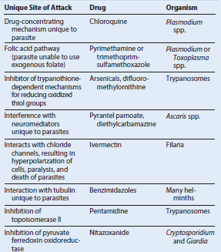

Mechanisms of Action and Clinical Indications for the Major Antiparasitic Agents
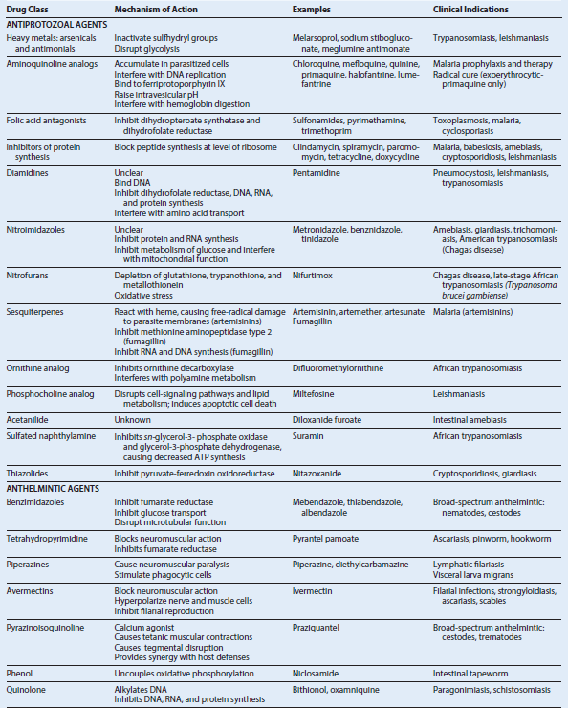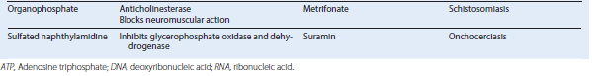
INTESTINAL AND UROGENITAL PROTOZOA
AMEBAE (AMOEBOZOA)
Trigger Words-Protozoa, amebae, trophozoite, cyst, intestinal amebiasis, extraintestinal amebiasis, hepatic amebiasis, flask-shaped ulcer, Entamoeba
Biology, Virulence, and Disease
• Primitive unicellular organisms with a simple two-stage life cycle
• Motility accomplished by extension of a pseudopod (false foot)
• Most amebae found in humans are commensal organisms
• Human pathogens: Entamoeba histolytica (most important), E.polecki
Epidemiology
• E. histolytica has worldwide distribution, with highest incidence in tropical and subtropical regions
• As many as 50% of the population in some areas are infected (average prevalence, 10% to 15%); U.S. prevalence is 4% to 5%
• Many carriers asymptomatic; pass cysts in stool (reservoir)
• Main source of food and water contamination is asymptomatic carrier who passes cysts
Diagnosis
• Microscopic examination of stool allows identification of cysts and trophozoites of E. histolytica
• Must differentiate from nonpathogenic and commensal species of amebae
• Specific serologic tests can confirm diagnosis
• Examination of stool samples may be negative in extraintestinal amebiasis
• Newer diagnostic approaches: fecal antigen, PCR, DNA probe
Treatment, Prevention, and Control
• Acute amebiasis treated with metronidazole, followed by iodoquinol, diloxanide furoate, or paromomycin
• Carrier state may be eradicated with iodoquinol, diloxanide furoate, or paromomycin
• Elimination of cycle of infection requires introduction of adequate sanitation measures, education about routes of transmission, chlorination, and filtration of water supplies
• Travelers to developing countries should avoid consumption of water (including ice cubes), avoid unpeeled fruits and raw vegetables, boil water, and thoroughly clean fruits and vegetables before consumption
CILIATES (METAMONADA [FORMERLY FLAGELLATES])
Trigger Words-Giardiasis, trichomoniasis, worm egg, contaminated stream, stool antigen test, cilia, wet mount, diarrhea, IgA deficiency
Biology, Virulence, and Disease
• Clinically important Metamonada: Giardia duodenalis (lamblia/intestinalis), Dientamoeba fragilis, Trichomonas vaginalis
• G. duodenalis life cycle has both cyst and trophozoite stages; D. fragilis has a trophozoite stage (cyst stage in mice); T. vaginalis has only a trophozoite stage
• Most flagellates move by lashing of cilia that pull organism through fluid environments
• Infection with G. duodenalis initiated by ingestion of cysts; asymptomatic carriage (50% of infected individuals); symptomatic disease ranges from mild diarrhea to a severe malabsorption syndrome
• Most infections with D. fragilis asymptomatic
• T. vaginalis causes urogenital infections
• Diseases produced by Metamonada result from mechanical irritation, inflammation of gastrointestinal and genitourinary (Trichomonas) mucosa
Epidemiology
• G. duodenalis has a worldwide distribution
• Giardiasis acquired by fecal-oral route
• Risk factors for giardiasis: poor sanitary conditions, travel to known endemic areas, consumption of inadequately treated water, day-care centers, oral-anal sexual practices
• D. fragilis has a worldwide distribution; transmission by fecal-oral and oral-anal routes
• T. vaginalis has a worldwide distribution; transmission primarily by sexual intercourse
Diagnosis
• Giardia may be detected by microscopic examination of fecal samples or duodenal aspirates
• Detection of Giardia fecal antigen by enzyme immunoassay, immunofluorescent microscopy
• Infection with D. fragilis diagnosed by microscopic examination of fecal specimens
• Trichomoniasis: microscopic examination of vaginal or urethral discharge
Treatment, Prevention, and Control
• Drug of choice for treatment of giardiasis (both symptomatic patients and carriers): metronidazole or nitazoxanide; alternatives: furazolidone, tinidazole, paromomycin, albendazole, quinacrine
• Prevention and control of giardiasis involves avoidance of contaminated water and food
• No consensus on best approach for treating D. fragilis infections; infection can be avoided by adequate sanitary conditions
• Drug of choice for trichomoniasis is metronidazole; personal hygiene, avoidance of shared toilet articles and clothing, and safe sexual practices are important preventive actions
CILIATES (CILIOPHORA)
Trigger Words - Macronucleus, pig feces, cytostome, cilia, intestinal ulceration
Biology, Virulence, and Disease
• Protozoan organisms whose locomotion involves coordinated movement of rows of hairlike structures (cilia)
• Neobalantidium coli: only Ciliophora parasite of humans
• N. coli has a funnel-like primitive mouth called a cytostome, a large and small nucleus involved in reproduction, food vacuoles, and two contractile vacuoles
• Disease produced by N. coli is similar to amebiasis; symptoms include abdominal pain, tenderness, tenesmus, nausea, anorexia, watery stools with blood and pus, ulceration of intestinal mucosa; extraintestinal infection very rare
Epidemiology
• N. coli distributed worldwide; swine and monkeys most important reservoirs
• Infections transmitted by fecal-oral route
• Outbreaks associated with contamination of water supplies with pig feces
• Person-to person spread has been implicated in outbreaks
• Risk factors include contact with swine and substandard hygienic conditions
Diagnosis
• Microscopic examination of feces for trophozoites and cysts
Treatment, Prevention, and Control
• Drug of choice is tetracycline; iodoquinol and metronidazole are alternatives
• Important preventive measures: personal hygiene, maintenance of sanitary conditions, careful monitoring of pig feces
SPOROZOA
Trigger Words-Coccidia, oocyst, chronic diarrhea, acid-fast, fecal antigen, waterborne transmission, contaminated fruits and vegetables
Biology, Virulence, and Disease
• Sporozoa constitute a very large group of protozoa called Apicomplexa or Coccidia
• All sporozoans demonstrate typical characteristics: asexual (schizogony) and sexual (gametogony) reproduction; share alternative hosts
• Intestinal sporozoan: Cystoisospora belli, Sarcocystis spp., Cryptosporidium spp., Cyclospora cayetanensis
• C. belli: coccidian parasite of intestinal epithelium; causes malabsorption syndrome
• Sarcocystis spp. can be detected in stool samples; nausea, abdominal pain, and diarrhea after ingestion of infected meat; muscular infections can occur if sporocysts ingested
• Cryptosporidium spp. cause intestinal disease, usually self-limited enterocolitis characterized by watery diarrhea without blood
• Cyclospora: illness self-limited in immunocompetent hosts, prolonged in HIV infected individuals
Epidemiology
• Cystoisospora organisms distributed worldwide; disease frequent in patients with AIDS; infection reported with increasing frequency in both healthy and immunocompromised patients
• Sarcocystis spp. are isolated from pigs and cattle
• Cryptosporidium spp. are distributed worldwide
• C. hominis and C. parvum cause most human infections; C. ubiquitum and C. felis are emerging human pathogens
• Cyclospora: worldwide distribution; infection acquired through contaminated water; outbreaks correlated with consumption of contaminated fruits and vegetables
Diagnosis
• C. belli infection best diagnosed by careful examination of concentrated stool sediment
• Sarcocystis spp. sporocysts may be detected in human stool specimens
• Cryptosporidium spp. may be detected in unconcentrated stool specimens from immunocompromised patients with diarrhea
• Diagnosis of cyclosporiasis is based on microscopic detection of oocysts in stool
• Both Cryptosporidium and Cyclospora infections may be diagnosed by PCR
Treatment, Prevention, and Control
• C. belli: treatment of choice is trimethoprim-sulfamethoxazole; prevention and control effected by maintaining personal hygiene and sanitation, avoiding oral-anal sexual contact
• No known treatment for intestinal or muscular sarcocystosis in humans
• No broadly effective therapy has been developed for managing Cryptosporidium infections in immunocompromised patients; nitazoxanide is approved by the FDA for the treatment of cryptosporidiosis in nonimmunocompromised individuals older than 12 months
• Cyclosporiasis has been treated with modest success using trimethoprim sulfamethoxazole
BLOOD AND TISSUE PROTOZOA
PLASMODIUM
Trigger Words-Malaria, quotidian, tertian, quartan, blackwater fever, cerebral malaria, benign tertian, malignant tertian, multiple ring forms, gametocytes, Anopheles mosquito, tropics and subtropics, prophylaxis
Biology, Virulence, and Disease
• Plasmodia: coccidian or sporozoan parasites of RBCs
• Five species that infect humans share a common life cycle
• Routes of acquisition: mosquito, transfusion, needle sharing, congenital
• P. falciparum produces daily (quotidian) chills and fever with nausea, vomiting, diarrhea progressing to tertian (36 to 48 hours) periodicity with fulminating disease (malignant tertian); no persistent liver stage
• P. knowlesi produces daily (quotidian) fever, chills, headache, rigors, abdominal pain, cough (severe symptoms in 7% of cases; respiratory distress and hepatorenal failure); no persistent liver stage
• P. vivax causes “benign tertian malaria” with paroxysms of fever and chills every 48 hours; a spectrum of severe, life-threatening syndromes similar to that with P. falciparum may be seen; a liver stage may cause relapses and recrudescence’s
• P. ovale causes benign tertian malaria similar to that of P. vivax with both relapses and recrudescence
• P. malariae has a long (18 to 40 days) incubation period and causes a moderate to severe disease with a 72-hour (quartan or malarial malaria) periodicity; no persistent liver stage
Epidemiology
• Infection with Plasmodium spp. Accounts for 216 million episodes with approximately 500,000 deaths annually, 90% of which are in Africa
• Vector is the Anopheles mosquito, which is widely distributed in tropical, subtropical, and temperate regions
• P. falciparum: occurs almost exclusively in tropical and subtropical regions
• P. knowlesi: infects Old World Monkeys, and increasingly humans, in Malaysia and neighboring countries throughout Southeast Asia
• P. vivax: widest geographic distribution (tropics, subtropics, temperate regions); 80% of cases occur in South America and Southeast Asia
• P. ovale: distributed primarily in tropical Africa; also found in Asia and South America
• P. malariae: occurs in same tropical and subtropical areas as other malarial parasites but less prevalent
Diagnosis
• Most widely used method: detection of parasites in thick and thin blood filmsstained with Giemsa or Wright stain
• Antigen detection using an RDT; used in both the field and diagnostic laboratories as an adjunct to microscopic examination of blood films
Treatment, Prevention, and Control
• Treatment of malaria is based on history regarding travel to endemic areas, prompt clinical review and differential diagnosis, accurate and rapid laboratory work, and correct use of antimalarial drugs
• Chloroquine or parenteral quinine is drug of choice for susceptible strains of Plasmodium; widespread resistance to chloroquine seen with P. falciparum and P. vivax
• Chemoprophylaxis with chloroquine, doxycycline, Malarone, or mefloquine coupled with avoiding mosquito bites (netting, insect repellents, clothing) required for prevention
• Elimination of mosquito breeding places
BABESIA
Trigger Words-Babesia, zoonosis, ticks, tetrad forms, splenectomy, intracellular, RBC
Biology, Virulence, and Disease
• Intracellular sporozoan parasites, morphologically resemble plasmodia
• Zoonosis infecting a variety of animals
• Babesia microti: usual cause of babesiosis in United States; transmitted by Ixodes ticks
• Incubation period of 1 to 4 weeks
• Symptoms: general malaise, fever without periodicity, headache, chills, sweating, fatigue, weakness • Hemolytic anemia coupled with renal failure can occur
• Splenectomy or functional asplenia, immunosuppression, HIV infection, advanced age increase susceptibility to infections and more severe disease
Epidemiology
• >70 different species of Babesia found in Africa, Asia, Europe, North America
• Ixodes dammini: tick vector along U.S. northeastern seaboard
• Natural reservoir hosts: field mice, voles, other small rodents
• Disease may be severe in HIV-infected individuals
• B. microti increasingly transmitted by blood transfusions
Diagnosis
• Examination of blood smears is diagnostic method of choice
• Serologic tests and PCR also used to diagnose babesiosis
Treatment, Prevention, and Control
• Treatment of choice for mild to moderate illness: combination of atovaquone and azithromycin
• Treatment for severe disease: clindamycin, quinine, exchange transfusion
• Protective clothing, insect repellents can minimize tick exposure
• Prompt removal of ticks can be protective
TOXOPLASMA GONDII
Trigger Words-Cat feces, raw meat, lymphadenitis, CNS lesion, encephalomyelitis, cat litter, congenital infection, AIDS
Biology, Virulence, and Disease
• Typical coccidian intracellular parasite found in a wide variety of animals, including birds and humans
• Essential reservoir host: common house cat and other felines
• Most T. gondii infections asymptomatic
• Symptoms occur when parasite moves from blood to tissues; include fever, chills, headaches, myalgia, lymphadenitis, fatigue
• Chronic disease marked by hepatitis, encephalomyelitis, and myocarditis
• Chorioretinitis may lead to blindness
• Congenital infection has serious sequelae
• Reactivation of cerebral toxoplasmosis is a major cause of encephalitis in patients with AIDS
Epidemiology
• Human infections ubiquitous
• Infection from ingestion of improperly cooked meat from intermediate-host animals or ingestion of infective oocysts from contaminated cat feces
• Transplacental infection can occur during pregnancy
• Rate of severe infection affected by patient’s immune status
• Illness in immunocompromised host believed to be caused by reactivation of previously latent infection rather than new exposure to organism
Diagnosis
• Increasing antibody titers documented inserially collected blood specimens
• Panel of tests (TSP) is used to determine recent versus past acquisition of infection
• Diagnosis of Toxoplasma encephalitis usually involves imaging study of brain
• Microscopy, serologic, and moleculartechniques may be required for definitive diagnosis
Treatment, Prevention, and Control
• Treatment of choice: initial high-dose regimen of pyrimethamine plus sulfadiazine followed by lower doses of both drugs indefinitely (AIDS patients and other immunocompromised patients)
• Clindamycin or spiramycin may be used in first trimester of pregnancy
• High-risk patients may be considered for prophylaxis
• Additional preventive measures: avoid consumption and handling of raw or undercooked meat, avoid exposure to cat feces
LEISHMANIA
Trigger Words-Kala-azar, Dumdum fever, cutaneous and mucocutaneous disease, visceral leishmaniasis, sand fly, post–kala-azar dermal leishmaniasis
Biology, Virulence, and Disease
• Leishmania: obligate intracellular parasites transmitted from animal to human or human to human by bites from infected female sand fly
• Many different species can infect humans, producing a variety of diseases (cutaneous, diffuse cutaneous, mucocutaneous, visceral)
• Clinical syndromes depend on species involved; most common species: cutaneous (L. tropica), mucocutaneous (L. braziliensis), visceral (L. donovani, L. infantum), post–kala-azar dermal leishmaniasis (L. donovani)
Epidemiology
• Natural reservoirs: rodents, possums, anteaters, sloths, dogs, cats
• Infection may be transmitted by animalvector- human or human-vector-human cycle, by direct contact with infected lesion, or mechanically by flies
• Mucocutaneous leishmaniasis most often occurs in Bolivia, Brazil, Peru; cutaneous leishmaniasis much more widespread throughout Middle East and in focal areas of South America
• Visceral leishmaniasis (kala-azar, Dumdum fever): ≈50,000 cases per year, 90% localized to Bangladesh, Brazil, India, Nepal, Sudan
Diagnosis
• Diagnosis of visceral, cutaneous, or mucocutaneous leishmaniasis made on clinical grounds in endemic areas
• Definitive diagnosis depends on detecting amastigotes in clinical samples or promastigotes in culture; molecular techniques have been used for diagnosis, prognosis, and species identification
Treatment, Prevention, and Control
• Drug of choice for all forms of leishmaniasis is the pentavalent antimonial compound sodium stibogluconate (Pentostam)
• Fluconazole and miltefosine efficacious in cutaneous disease
• Stibogluconate remains drug of choice for mucocutaneous leishmaniasis
• Prevention involves prompt treatment of human infections and control of reservoir hosts, along with vector control
TRYPANOSOMES
Trigger Words-Sleeping sickness, tsetse fly, reduviid bugs, chagoma, Romaña sign, megaesophagus, Winterbottom sign, Chagas disease
Biology, Virulence, and Disease
• Trypanosoma, a hemoflagellate, causes two distinctly different forms of disease: African trypanosomiasis and American trypanosomiasis
• African trypanosomiasis (sleeping sickness): chronic disease of several years’ duration, transmitted by tsetse flies, fatal without treatment
• American trypanosomiasis (Chagas disease): asymptomatic, acute, or chronic forms, transmitted by reduviid bugs
Epidemiology
• T. brucei gambiense limited to tropical West and Central Africa, correlating to range of tsetse fly vector
• T. b. rhodesiense found in East Africa, especially cattle-raising countries
• Domestic and wild game animals act as reservoir hosts for T. b. rhodesiense
• T. cruzi occurs widely in both reduviid bugs and a wide variety of reservoir animals in North, Central, and South America
• Because of the chronic nature of infection, screening of solid organ and blood donors for Chagas disease has become important
Diagnosis
• Agents of sleeping sickness can be demonstrated in blood films, aspirations from lymph nodes, and concentrated spinal fluid
• T. cruzi can be demonstrated in blood films early in acute stage of disease
Treatment, Prevention, and Control
• Suramin: drug of choice for treating acute blood and lymphatic stages of both Gambian and Rhodesian forms of sleeping sickness; pentamidine is an alternative
• Melarsoprol: drug of choice for CNS disease
• Effective control measures: integrated approach to reduce human reservoir of infection, use of fly traps and insecticide
• Drugs of choice for treatment of Chagas disease: benznidazole and nifurtimox
• Vector control important: insecticide, eradication of nests, construction of homes to prevent nesting of bugs
CNS, Central nervous system; PCR, polymerase chain reaction; RBC, red blood cell; RDT, rapid diagnostic test; TSP, T. gondii serologic profile.
MEDICALLY IMPORTANT BLOOD AND TISSUE PROTOZOA
Plasmodium species
Babesia species
Toxoplasma species
Sarcocystis species
Acanthamoeba species
Balamuthia species
Naegleria species
Leishmania species
Trypanosoma species

Human Malarial Parasites
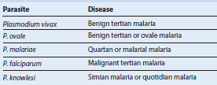

Leishmaniasis in Humans
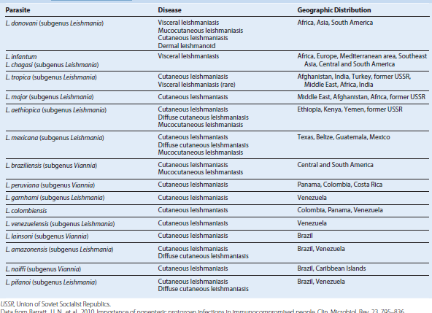
Trypanosoma Species Responsible for Human Diseases